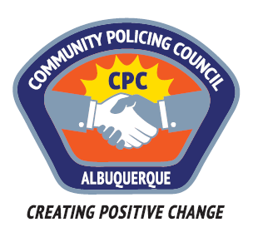
Southwest Area Command Community Policing Council

Meeting Minutes

Wednesday, November 16th 6:00-7:30pm
Patrick J. Baca Library
8081 Central Ave NW, Albuquerque, NM
- Call to order- Chair; Nick Nieto
- Roll call was done. In attendance were Nick Nieto, Jan LaPitz, Larry LaPitz, Lt. Michelle Campbell, Father Michael Zocholl, Mary Salazar, Nicole Chavez-Lucero and Officer Anthony Sedillo along with eight other guests.
- Approval of minutes from last meeting; 10/12/2016 and 09/14/2016 minutes was approved with some minor changes.
- New business/Erika Wilson; Director 911 Call Center; Presentation regarding the operations of the 911 Call center. Handouts were also given out on Tips for calling 911, How to make an Emergency Call to 911. Another hand out on Landline vs. Cell Phone for your home.
Ms. Wilson also advised that they are looking to hire 911 operator and dispatchers. Starting pay is at $17.25/hour for operators and $18.10/hour for dispatchers.
- Open issues/Old Business was discussed.
Chair Nick Nieto discussed the meeting all CPC chairs attended at the U.S. Attorney General’s office. The groups was told that Mayor Berry did not attend the CPC meetings because when he first started the Community Policing Councils, he was told that he should not attend because the citizens may view him being there are politicizing it. The group was okay with this and it makes sense to everyone that was in the meeting.
The City advised that facilitators are being hired; they are looking for other companies to contract with to assist.
Recruitment for more CPC members and attendees was discussed. The information regarding CPC’s was in November’s water bill. Jan asked if APD could add internet ads for the water department for those that get paperless bills as well as asking PNM if we could put ads in their bills.
Nicole is actively pursuing new CPC membership. Has brochures up at libraries, community centers, faith based locations.
Nick stated that Shawn Willoughby (President of the Police Union) is attending and speaking at CPC meetings if the group would like him to be a speaker.
- Father Michael advised that he will have the Non-emergency recommendation ready to present at January’s CPC meeting.
- Adjournment

